Arpita Kulkarni

Journal for Communication and Signal Processing

% Generation of sine wave

a=5;

f=5;

t=0:1/(20*f):1;

pi=3.142;

x=a*sin(2*pi*f*t);

plot(t,x);

xlabel('Time in s')

ylabel('x(t)')

title('Sinusoidal signal of F Hz')

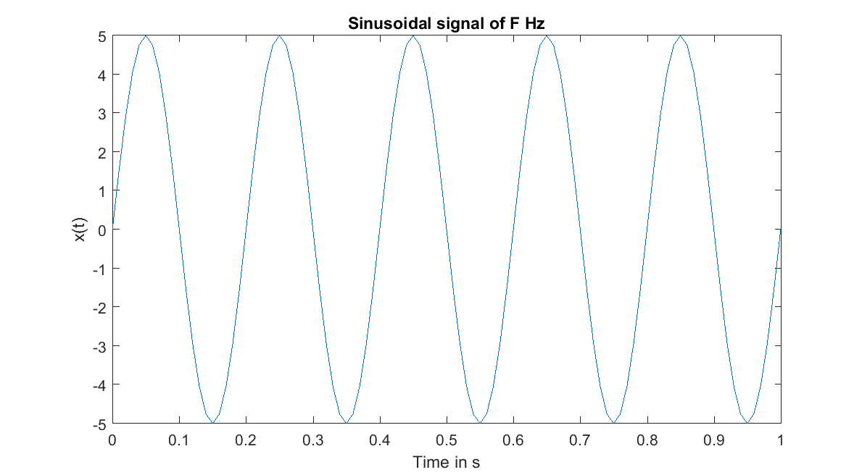

% Generation of sine wave of different Phase

a=5;

f=5;

t=0:1/(20*f):1;

pi=3.142;

x=a*sin(2*pi*f*t);

y=a*sin((2*pi*f*t)+pi/2);

w=a*sin((2*pi*f*t)+3*pi/2);

z=a*sin((2*pi*f*t)+pi);

plot(t,x);

xlabel('Time in s')

ylabel('x(t)')

title('Sinusoidal signal of F Hz')

hold on;

plot(t,w)

plot(t,y)

plot(t,z)

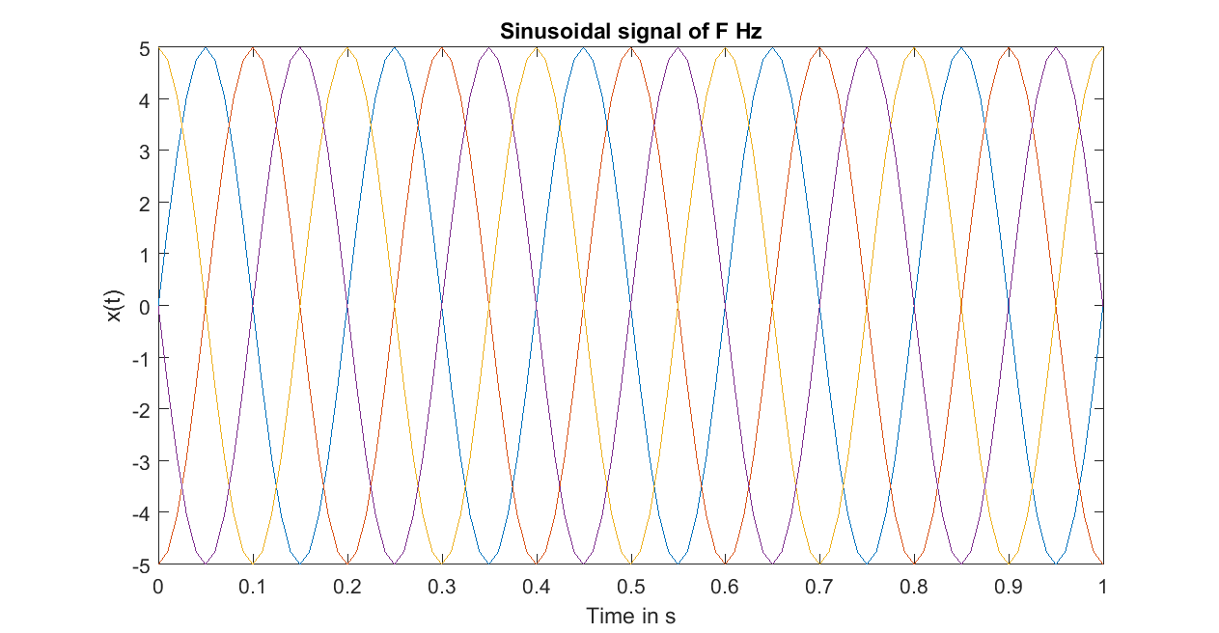

% Amplitude Modulation

clc

clear all

close all

% Message signal frequency

fm=10;

% Carrier wave frequency

fc=100;

Am=5;

Ac=10;

t=0:0.0002:1;

mt=Am*cos(2*pi*fm*t);

ct=Ac*cos(2*pi*fc*t);

st=Ac.*(1+(0.5*cos(2*pi*fm*t))).*cos(2*pi*fc*t);

st1=Ac.*(1+(1*cos(2*pi*fm*t))).*cos(2*pi*fc*t);

st2=Ac.*(1+(1.5*cos(2*pi*fm*t))).*cos(2*pi*fc*t);

figure(1)

subplot(5,1,1), plot(t,mt,'r');

ylabel('Message signal');

xlabel('t');

title('Amplitude modulation');

subplot(5,1,2), plot(t,ct);

ylabel('Carrier signal');

xlabel('t');

subplot(5,1,3), plot(t,st);

title('Mu<1');

xlabel('t');

hold on;

plot(t,mt,'r');

subplot(5,1,4), plot(t,st1);

title('with Mu=1');

xlabel('t');

hold on;

plot(t,mt,'r');

subplot(5,1,5), plot(t,st2);

title('with Mu>1');

xlabel('t');

hold on;

plot(t,mt,'r');

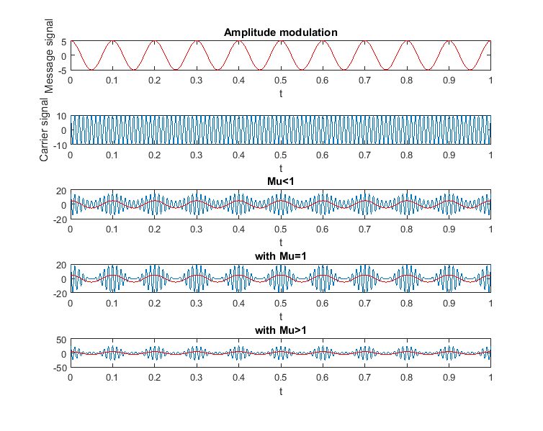

% Sampling Theorem

a=10;

f=5;

t=0:1/(20*f):2;

x=a/2 *sin(2*pi*f*t);

subplot(4,2,1);

%figure(1)

plot(t,x);

xlabel('time in sec')

ylabel('x(t)')

title('sinusoidal signal of F hz')

% Continuos plot

a=10;

f=5;

t=0:1/(20*f):2;

x=a/2 *sin(2*pi*f*t);

subplot(4,2,2);

%figure(1)

plot(t,x);

xlabel('time in sec')

ylabel('x(t)')

title('sinusoidal signal of F hz')

% Sampling the sine wave

% Under Sampling

Fs1=8;

t1=0:1/(Fs1):2;

x1=a/2*sin(2*pi*f*t1);

subplot(4,2,3);

%figure(2)

stem(t1,x1);

xlabel('time in sec')

ylabel('x1(t)')

title('Sampled sinusoidal signal of Fs<2F Hz')

% Critically Sampling

Fs1=10;

t1=0:1/(Fs1):2;

x2=a/2*sin(2*pi*f*t1);

subplot(4,2,5);

%figure(3)

stem(t1,x2);

xlabel('time in sec')

ylabel('x2(t)')

title('Sampled sinusoidal signal of Fs=2F Hz')

% Over Sampling

Fs1=30;

t1=0:1/(Fs1):2;

x3=a/2*sin(2*pi*f*t1);

subplot(4,2,7);

%figure(4)

stem(t1,x3);

xlabel('time in sec')

ylabel('x3(t)')

title('Sampled sinusoidal signal of Fs>2F Hz')

% Sampling the discrete sine wave

% Under Sampling

Fs1=8;

t1=0:1/(Fs1):2;

x1=a/2*sin(2*pi*f*t1);

subplot(4,2,4);

%figure(2)

plot(t1,x1);

xlabel('time in sec')

ylabel('x1(t)')

title('Sampled sinusoidal signal of Fs<2F Hz')

% Critically Sampling

Fs1=10;

t1=0:1/(Fs1):2;

x2=a/2*sin(2*pi*f*t1);

subplot(4,2,6);

%figure(3)

plot(t1,x2);

xlabel('time in sec')

ylabel('x2(t)')

title('Sampled sinusoidal signal of Fs=2F Hz')

% Over Sampling

Fs1=30;

t1=0:1/(Fs1):2;

x3=a/2*sin(2*pi*f*t1);

subplot(4,2,8);

%figure(4)

plot(t1,x3);

xlabel('time in sec')

ylabel('x3(t)')

title('Sampled sinusoidal signal of Fs>2F Hz')

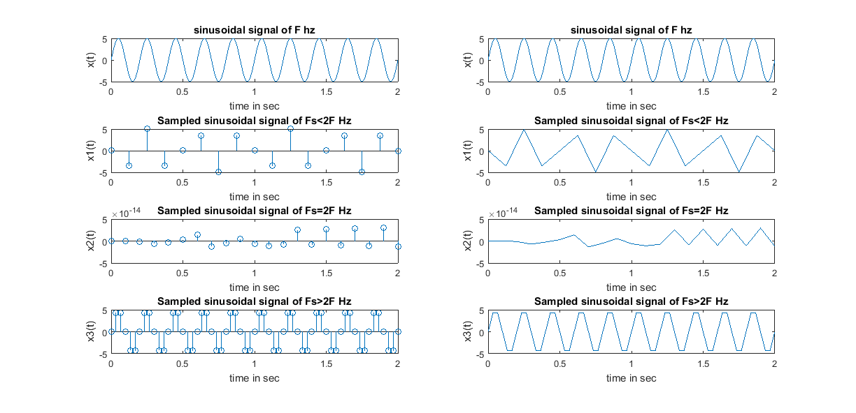

% Time and frequency domain waveform of modulated signal which has phase

% Power Spectral Density Spectrum

% reversal of 180 degree using matlab

clear all;

close all;

clc;

fm=0.5;

Am=0.85;

fc=250;

Ac=1;

t=0:0.15:10;

mt=Am*cos(2*pi*fm*t);

ct=Ac*cos(2*pi*fc*t);

mod_index=0.85;

st=Ac*(1+(mod_index)*cos(2*pi*fm*t)).*cos(2*pi*fc*t);

s=st.*ct;

w=(fc-fm)/(fc+fm);

[b,a]=butter(2,w);

dmodmt=filter(b,a,s);

dmodmt=dmodmt-1;

subplot(3,2,1);

plot(t,mt); xlabel('time');

ylabel('m(t)');

title('Message signal');

subplot(3,2,2);

plot(t,ct);

xlabel('time');

ylabel('c(t)');

title('Carrier signal');

subplot(3,2,3);

plot(t,st);

xlabel('time');

ylabel('s(t)');

title('Amplitude modulated signal');

subplot(3,2,4);

plot(t,dmodmt);

xlabel('time');

ylabel('Demodulated m(t)');

title('Demodulated signal');

subplot(3,2,5);

[Pxx,F] = periodogram(st,[],length(st),fc);

plot(F,10*log10(Pxx));

title('PSD');

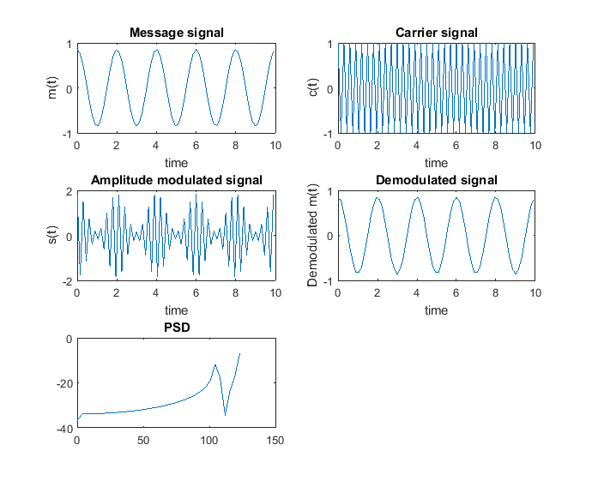

% Linear convolution program

clc;

clear all;

close all;

disp('linear convolution program');

x=[1,3,2,1];

%x=input('Enter x(n) : ');

m=length(x);

h=[1,-1,2];

%h=input('Enter h(n) : ');

n=length(h);

x=[x,zeros(1,n)];

subplot(3,2,1), stem(x);

title(['i/p sequencce x(n) is: ', num2str(x)]);

xlabel('n');

ylabel('x(n)');grid;

h=[h,zeros(1,m)];

subplot(3,2,2), stem(h);

title(['i/p sequencce h(n) is: ', num2str(h)]);

xlabel('n');

ylabel('h(n)');grid;

disp('convolution of x(n) & h(n) is y(n):');

y=zeros(1,m+n-1);

for i=1:m+n-1

y(i)=0;

for j=1:m+n-1

if(j<i+1)

y(i)=y(i)+x(j)*h(i-j+1);

end

end

end

subplot(3,2,[3,4]),stem(y);

title('convolution of x(n) & h(n) is :');

xlabel('n');

ylabel('y(n)');grid;

c= conv(x,h);

subplot(3,2,[5,6]),stem(y);

title('convolution of x(n) & h(n) is :');

xlabel('n');

ylabel('y(n)');grid;

disp(x)

disp(h)

disp(y)

disp(c);

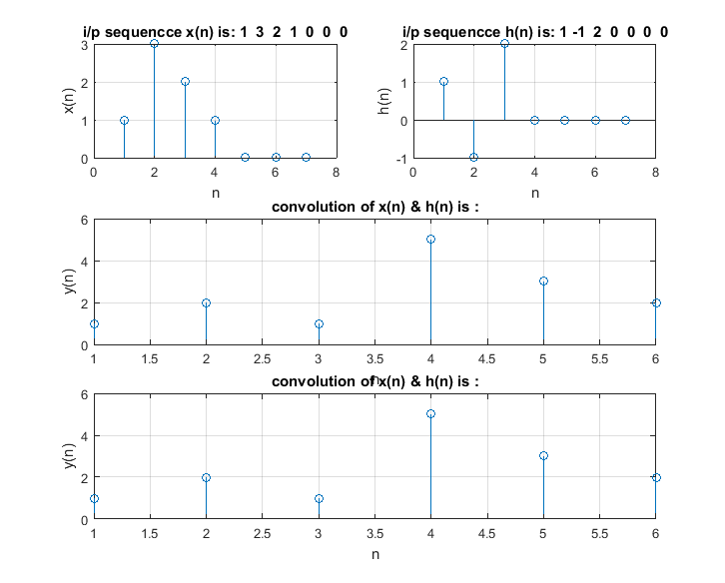

% Linear correlation program

clc;

clear all;

close all;

disp('linear correlation program');

x=[4 3 2 1];

%x=input('Enter x(n) : ');

y=[2 1 -1 3 2];

%h=input('Enter y(n) : ');

n=length(y);

R_inbuilt= xcorr(x,y);

disp(R_inbuilt);

subplot(3,2,1), stem(x);

title(['i/p sequencce x(n) is: ', num2str(x)]);

xlabel('n');

ylabel('x(n)');grid;

subplot(3,2,2), stem(y);

title(['i/p sequencce y(n) is: ', num2str(y)]);

xlabel('n');

ylabel('y(n)');grid;

disp('correlation of x(n) & y(n) is R:');

x=[zeros(1,n),x,zeros(1,n)];

m=length(x);

R=zeros(1,m-n-1);

for i=1:m-n-1

for j=1:n

R(i)= R(i)+ x(i+j)* y(j);

end

end

subplot(3,2,[3,4]),stem(R);

title('correlation of x(n) & y(n) is :');

xlabel('n');

ylabel('y(n)');grid;

subplot(3,2,[5,6]),stem(R_inbuilt);

title('correlation of x(n) & y(n) using Inbuilt function xcorr is :');

xlabel('n');

ylabel('y(n)');grid;

disp(x)

disp(y)

disp(R)

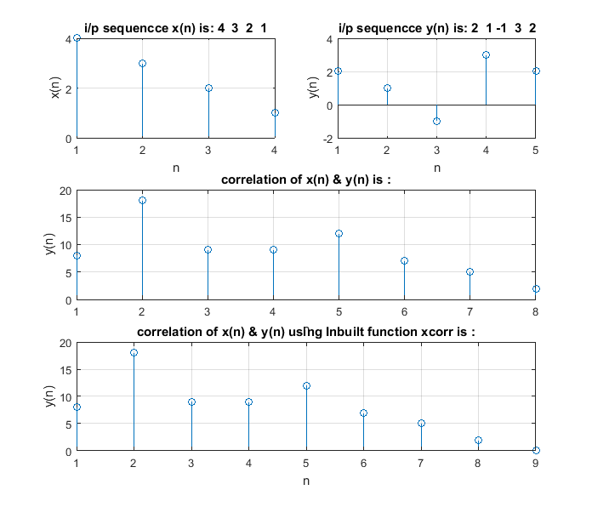

% Fast Fourier transform with spectrum

clc;

clear all;

close all;

% Time specifications:

Fc = 50;

Fc1 = 5; %hertz

Fs = 2*max(Fc,Fc1) +1; % samples per second

T = 1/Fs; % seconds per sample

t = 0: T : 1-T;

N = length(t);

% Message signal:

x = cos( 2*pi*Fc*t ) + 2 * sin(2*pi*Fc1*t);

%x= sin (2*pi*Fc*t)

figure(1)

subplot(2,1,1)

plot(t,x);

title('Message Signal')

%Fourier Transform:

Z=fft(x);

X=fftshift(Z);

% Frequency specifications:

f= - Fs/2 : Fs/N : (Fs/2)-1; %hertz

%plot the spectrum :

subplot(2,1,2)

stem(f,abs(X)/N );

xlabel ('Frequency (in hertz )');

title('Magnitude Response');

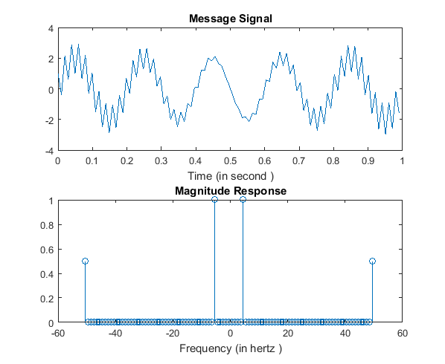

% Discrete Fourier Transform

clear all;

close all;

clc;

x=[0 1 2 -1 2 0];

n=length(x);

for k=1:n

X(k)=0;

for p=1:n

a=p-1;

b=k-1;

X(k)=X(k)+x(p)*exp(-1*1j*2*pi*a*b/n);

end

end

Y=fft(x);

figure(1);

subplot(3,1,1);

stem(x);

xlabel('Time in second');

title('Input Signal x(n)');

subplot(3,1,2);

stem(X);

xlabel('Frequency in hertz');

title(' Discrete Fourier Transform of x(n) : {X(k)}');

subplot(3,1,3);

stem(Y);

xlabel('Frequency in hertz');

title('DFT of x(n) using inbuilt function');

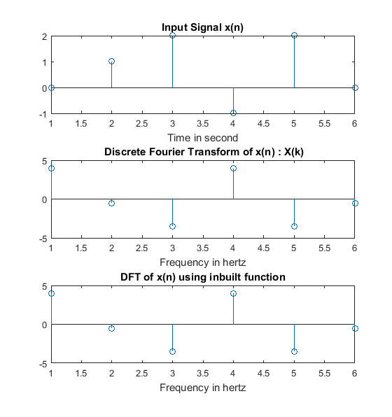

% Inverse Discrete Fourier Transform

clear all;

close all;

clc;

X=[2 -2+2j -2 -2-2j];

l=length(X);

for n=1:l

x(n)=0;

for k=1:l

a=n-1;

b=k-1;

x(n)=x(n)+X(k)*exp(1j*2*pi*a*b/l);

end

x(n)=x(n)/l;

end

y=ifft(X);

figure(2);

subplot(3,1,1);

stem(X);

title('Input Signal X(k)');

subplot(3,1,2);

stem(x);

title('Inverse Discrete Fourier Transform of X(k) : {x(n)}');

subplot(3,1,3);

stem(y);

title('IDFT of X(k) using inbuilt function');

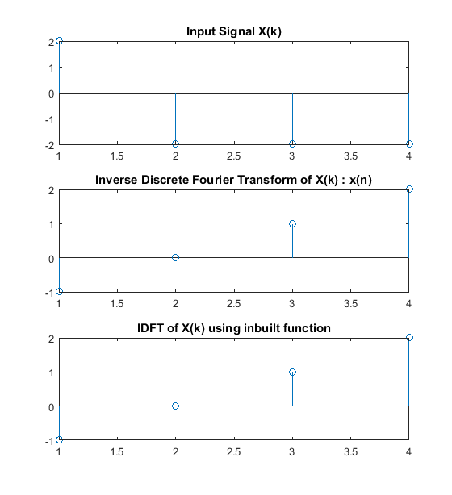

% DSBSC Modulation and Demodulation

clc;

close all;

clear all;

m=1;

Am=5;

fm=10;

Tm=1/fm;

t=0:Tm/100:6*Tm;

ym=Am*cos(2*pi*fm*t);

subplot(4,1,1);

plot(t,ym)

title ( 'Modulating Signal');

xlabel ( ' time (sec) ');

ylabel (' Amplitude (volt) ');

% carrier frequency

Ac=Am/m;

fc=fm*10;

Tc=1/fc;

yc=Ac*cos(2*pi*fc*t);

subplot(4,1,2);

plot(t,yc), grid on;

title ( ' Carrier Signal');

xlabel ( ' time(sec) ');

ylabel (' Amplitude (volt)');

% for DSBSC Modulation

y=ym.*yc;

subplot(4,1,3);

plot(t,y);

hold on;

plot(t,Ac*(ym));

hold on;

plot (t,-Ac*(ym));

axis;

title ( 'DSBSC Modulated wave ');

xlabel ( ' time(sec) ');

ylabel (' Amplitude (volt) ');

grid on;

% For DSBSC Demodulation

z=y.*yc;

subplot(4,1,4);

plot(t,z);

title ( 'DSBSC Demodulated wave ');

xlabel ( ' time(sec) ');

ylabel (' Amplitude (volt)

